
Hertfordshire Volleyball Association

2026 AGM – 07-Jun-2026 - 16:00 – The Red Lion (Hemel Hempstead)
Chaired by Angelo Evangelou, minutes by Patricia Russo
Attendance, apologies and absents

Club | Participant | Apologies | Absent
Harlow Bravos |  |  | £10 fine raised
Kings Langley | Angelo Evangelou (also HVA)  Thierry Quijo (also HVA)
MK City | Layne Walker
Red Eagles |  |  | £10 fine raised
Stortford Stags |  | £5 fine raised
Watford |  | £5 fine raised
Welwyn & Hatfield | Russell Franklin  Marzena Wisniewska (also HVA)
Werewolves St Albans | Aileen Christine Tomasulo
Wycombe Eagles | Patricia Russo (also HVA)  Mateusz Rogoz (also HVA)  Vytautas Kravcenka

Agenda
- Minutes of previous meeting
The minutes of the previous meeting were accepted with no issues raised.

- Chair report
No issues were raised for discussion.

- Secretary report
No issues were raised for discussion.

- Finance update
The current balance stands at : £3,842.33
Members were advised that there are still some pending outgoings to the engraving of cups and shields.

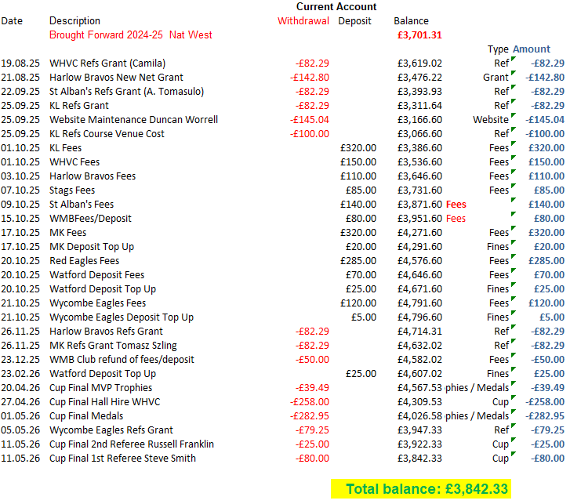

- Fixtures report
All matches for the season have now been completed.
Teams are reminded to ensure that pictures of scoresheets submitted are clear and legible, particularly the team list. The Committee will investigate options for digitalising scoresheets to improve the accuracy and readability of players details.

- New / withdrawing club / teams
There are currently no new clubs joining HVA, and no notifications of withdrawals have been received.

- Election of officials
No new nominations were received for committee positions.
All current officials were confirmed in their existing roles for the forthcoming year.
It was agreed that the bank account details will be updated accordingly.

- Rule amendments
Rule amendments were voted upon.

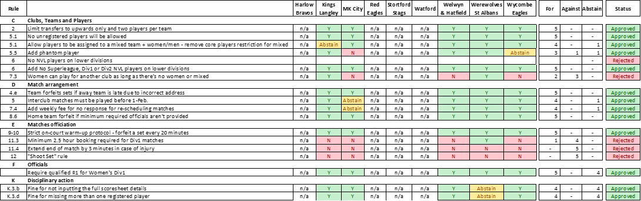

- Other discussion points
- Grants – A proposal regarding grants has been shared with clubs. The proposal will be put forward for a vote at the next meeting in September.
- Safeguarding – It was agreed that every affiliated club must prominently display the following on the home page or contact page of their official website:
  - A photograph of the Club Welfare Officer (CWO)
  - Direct contact details for the CWO and
  - A clear safeguarding reporting pathway outlining how concerns can be reported.
In addition, this information must be circulated by e-mail to all club members at least once per season.
- Formalised appeals procedure – A proposal for formalised appeals procedure has been shared with clubs and will be presented for a vote at the next meeting in September.
- League fixture set up – Concerns regarding the current fixture scheduling process were discussed. The issue has been acknowledged; however, it was noted that finding a balanced solution remains challenging. To help improve fixture distribution, it will be recommended that teams aim to play one home match and one away match per month were possible.
- Junior volleyball – Russell advised that he is not currently interested in establishing a formal junior league. Instead, he would support organising ad hoc matches and/or one-day tournaments to aid junior development. Russell will contact interested teams directly to coordinate arrangements.
- Recording forfeit result – Teams may enter a forfeit result as 25-0, 25-0, 25-0 within the results system. Once validated by the Competitions Secretary, the result will be amended to a forfeit to ensure no league points are awarded to the forfeiting team.
- Mixed team playing level – It was agreed that the mixed league should remain a competitive league. Teams consisting primarily of beginner players are encouraged to enter the Men’s Division 3 or Men’s Division 4 competitions instead.
- HVA constitution – The HVA Constitution was last amended in 2005 and requires updating. Committee members will review the current constitution and prepare a proposal for consideration.
- Referee course – HVA will organise a referee course in September, prior to the start of the new season. Clubs were reminded that HVA will fund one referee course place per affiliated club each season.

- Next meeting
Next meeting will take place in September. Details to follow.

