
Hertfordshire Volleyball Association

2025 Committee Meeting & Fixtures Meeting 20h00, 17th September 25
Chaired and minutes by Thierry Quijo
Attendance, apologies and absents
Present: Alex Iftime (HVA, MK City), Layne Walker (MK City), Russell Franklin (Welwyn & Hatfield), Duncan Worrell (HVA), Krzysztof Dabrowski (Red Eagles), Marzena Wisniewska (HVA, Welwyn & Hatfield), Angelo Evangelou (Kings Langley), Antonio De Grazia (Werewolves St Albans Volleyball Club), Giuseppe Vitellino (KLVC), Jonathan Allan (Stags), Logan Burney (KLVC), Maria Garzon (Harlow Bravos), Mariusz Olasik (WMB), Thierry Quijo (KLVC), Camila Garzon Jimenez (Welwyn & Hatfield)

Apologies: £5 fine raised
- Watford
- Wycombe Eagles Volleyball Club

Absent: £10 fine raised

Minutes of previous meeting
Available via the HVA website

Agenda
- Review and Agreement of Leagues for 25/26 season
New clubs’ presentation:
- Werewolves St Albans Volleyball Club (WSVC)
- Played in HVA before, during season 23/24 finished 3rd of M2. Did not take part for season 24/25
- They want to re-join HVA so that they play more matches and more competitive matches
- They want to enter two men’s team, one woman’s team and one mixed in HVA in the respective division: M1, M2, W1, X1 (TBC)
-WMB VOLLEYBALL CLUB
- They want to enter 1 Mixed team. Mariusz stated it is unsure the Mixed team will exist, and it may move to be included within RE. TQ stated, it is noted but will need to know asap, last try out at RE is this weekend 20/09 and will know by next week.
-Leagues 25/26 (Annexe: HVA)
- M1: 10 teams want to play in the M1, including the new club (Werewolves St Albans).
  - Proposal:
    - Departures: GNG and MD Eagle
    - New: Werewolves (WM1) in M1 (new club & team)
    - Demotions: Milton Keynes (MM2) and Kings Langley VC (KIN), both finished last of the league
    - Promoted: Welwyn & Hatfield (FAL) and Red Eagle (RM2) finishing top 2 of league
    - League will be with 8 teams
  - Dispute:
    - MM2 and KIN want to remain in M1, feeling M1 is more competitive than M2. TQ mentioned MM2 only won 1 match and KIN 3 matches (see annexe)
    - Red Eagle not keen to have 10 team in M1
  - Resolution: either triangular competition or imposed by HVA
    - Discussed during the call: 3 teams triangle competition between Wolves, MM2 and KIN. The winner will go in M1 and others to M2. Match in 3 straight sets, 1 day of competition.
      - Need to be organised by one of the 3 involved teams
      - Registered players on the scoresheet will be locked to that team for entirely season.
      - M1 rules are applicable
      - Result needs to be communicated by Sunday 28/09/2025
    - HVA (Acting committee, internal meeting): All 3 teams remain in M1, this will set the M1 league to 10 teams as previous year. If any teams feel there is too many teams in M1, they have the option to move to M2.

Action for the 3 concerned teams:
- Set the date and time for the “Triangle competition” following the M1 Div rules. In the event no result or disagreement, the HVA will impose the decision to keep the 3 teams in M1. Deadline to receive the result is 23:59 on Sunday 28th of September 2025.

- M2: 8 teams registered. The Mount is leaving HVA and Stags moving to Mixed team. New entry 1 team for Red Eagle (RM4), 1 for Milton Keynes Youth (MYA) and 1 for Werewolves (WM2)
  - Proposal:
    - MM2 and KIN: joining M2 demoted from M1
    - RM3 and RM4: moved to M3, RM3 finished last when removing The Mount and Stags, and RM4 is new
  - Issue:
    - Red Eagle not keen having no team in M2
  - HVA Solution:
    - RM3 remains in M2 and RM4 goes to M3

- M3: 5 teams registered. Harlow Bravos entering a new team (HB2) and Kings Langley 2 teams (PWN, RKS).
  - Proposal:
    - Red Eagle RM3 and RM4 moved to M3 from M2
  - Issue:
    - Same as M2
  - HVA Solution:
    - Same as above in M2

- Women: 10 teams registered.
New coming teams (4):
- Werewolves (ALP)
- Harlow Braovs (HBW)
- Red Eagle (RW2)
- Kings Langley (ACE)

- Mixed: 8 registered team.
New coming teams 5:
- WMB Volleyball (WMB)
- Werewolves (WX1)
- Welwyn & Hatfield (RAV)
- STAGS (STG) moved from M2
- Kings Langley (BOW)

- Chair and Secretary position
- Chair: Two nominations, Krzysztof (Red Eagle) and Angelo (Kings Langley VC).
  - Krzysztof: Increase his commitment to the league and feel Red Eagle, one of the largest club, should be more represented in the HVA
  - Angelo: Improve the engagement across the league and overall communication between the HVA and the clubs, and between clubs.
Action: all club will vote to elect a new Chair
- Secretary: Position remains vacant
  - Layne suggested the non-elected candidate should then fill the secretary position
  - Thierry mentioned the secretary position needs to be filled otherwise the HVA committee has the right to appoint the position to someone.

- Club & Teams Registrations (fees, deadlines, VE affiliations & Welfare requirements)
NEW Fees (reduced from previous year)
- £20 per club for affiliation
- £30 league entry and per team
- £20 Cup entry per team (optional)
- VE affiliations are available. Please provide your affiliation to Thierry

On top of it the above, new clubs need to pay £30 goodwill deposit (which is used for any fines). --> this needs to be paid before first match is played otherwise match is forfeit.

TASKS | OWNER | DEADLINE | COMMENTS
Submission of affiliation | Clubs | 28/09/2025 | Available now in VE
M1 Triangle Match | Warewolves  MK City  Kings Langley | 28/09/2025 | Inform HVA the results of the triangle match that will decide the team in M1. If no outcome HVA will decide (See annexe)
Fixtures spreadsheet (empty) | Fixtures secretary | 05/10/2024 | Online document, via google sheet
Fixtures spreadsheet (completed) | Teams | 12/10/2025 | Fixtures chair of each club to complete the fixtures spreadsheet.
Start of the league |  | 19/10/2025

The league can start as soon as two teams are ready to play each other and have returned their filled fixtures sheet back earlier.

- Reminders of new rules such as position for serving and receiving team, screening, double touch…

- AOB
- Following article 5e from the constitution, Duncan Worrell will remain in the EC without voting rights. Duncan helped to move the HVA to where it is now, it will be an asset to continue having him part of our HVA.
- Following the fixtures meeting, the Executive Committee (EC) held an internal discussion and requested that Alex remain a member of the EC in a non-voting capacity. Alex has agreed to continue in this role. His extensive network within Volleyball England, along with his refereeing expertise, are considered valuable assets to the HVA. This decision is made in accordance with Article 5e of the Constitution.
- Remind to all clubs and teams if they would like to film the match, it needs to have the approval from the opposition.
- Junior clubs will be highlighted on the HVA website and Facebook. The clubs are MK City, Harlow Bravos, WMB, Welwyn & Hatfield and Werewolves St Albans
- HVA in discussion with Herts Ladies VC (Div 2 East) to rejoin the HVA.
- Fixtures: discussion to use AI to prepare the fixtures, however, it will be most likely that we are going to use the spreadsheet.
- KR mentioned, having a slightly smaller M1 is better as they will tend to be in national and HVA cup champs.

NEXT MEETING:
- HVA Committee meeting: December 2025
Exact date and invite to be sent closer at the time by HVA Secretary.

Annexes:

HVA: Received = the club preference / Proposed = suggested during fixture meeting / HVA = decided league

M1 finishing table
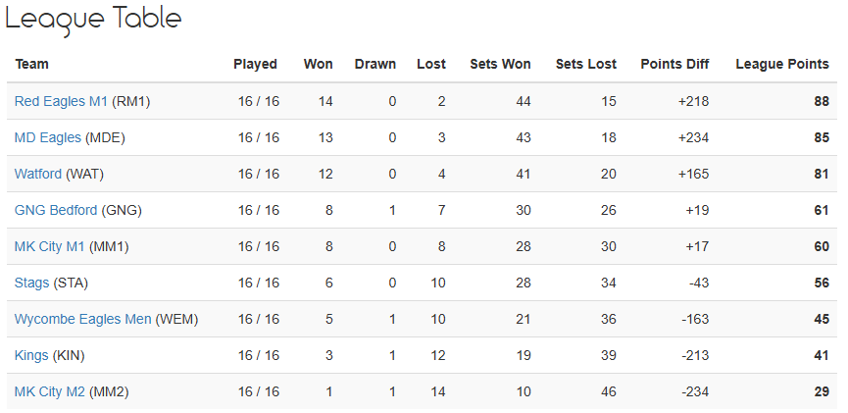

M2 finishing table
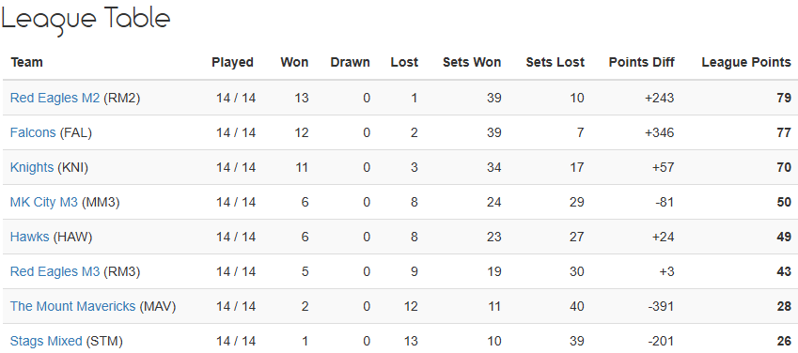

M3 finishing table
